Security Zones with ORM stack

Contents

1. Introduction 3
2. Workflow diagram to deploy the stack 3
3. Create stack for Security Zones 4
4. Plan the Job 6
5. Apply the Job 7
6. Verify in the Console 8
7. Destroy the stack 9

Introduction

Security Zones must contain resources in Oracle Cloud Infrastructure, including Compute, Networking, Object Storage, Block Volume and Database resources, comply with security policies. A security zone is associated with one or more compartments and a security zone recipe. When user create and update resources in a security zone, Oracle Cloud Infrastructure validates these operations against the list of policies that are defined in the security zone recipe.

Workflow diagram to deploy the stack

Below diagram shows how the Terraform Artifact are applied in the OCI. While creating a ORM stack, using terraform deliverables Init, Plan and Apply is the flow to provision the resource in the OCI. We can have the deliverables in any of below.

- GitLab/GitHub Repo
- Bitbucket
- Can be in folder/.zip in the local disk
- Object Storage Bucket
- Can be in compartment
- Oracle provided Template

Prerequisites
- Create security recipe

Create stack for Security Zones

Go to OCI Console Developer Services Resource Manager Stacks select the compartment Create Stack

My Configuration Folder Browse Select the “oracle_security_zone” folder that contains the terraform Upload

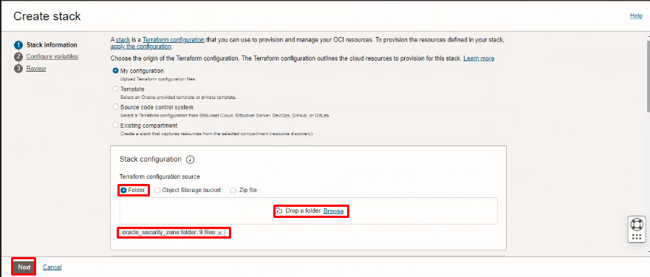

Select the parameters as per the below screen,
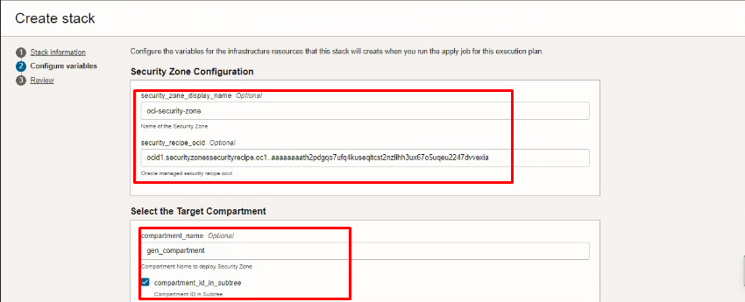
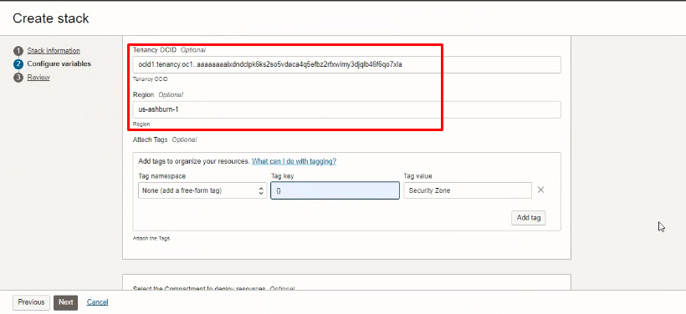

Click “NEXT”

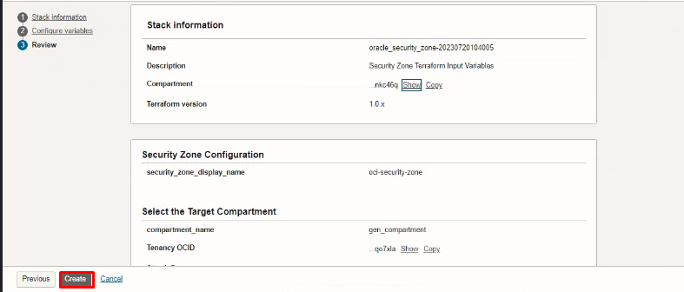
Click “CREATE”

Plan the Job

Click the “Plan”
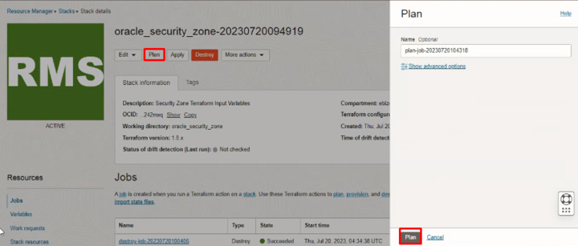

Verify the Plan is successful.

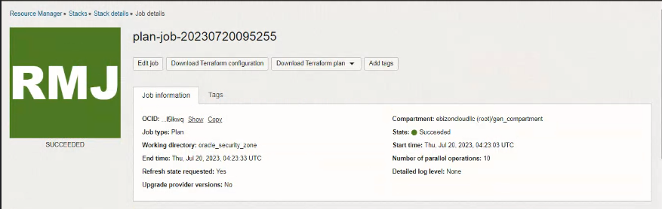
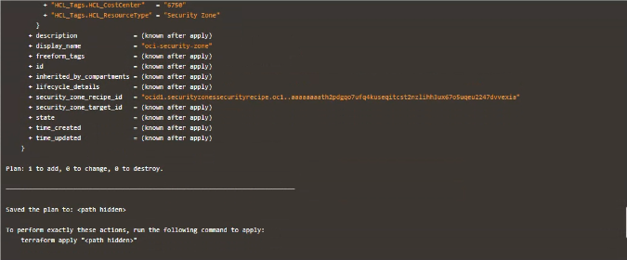

Apply the Job

Once the “plan” is success, now click “Apply”
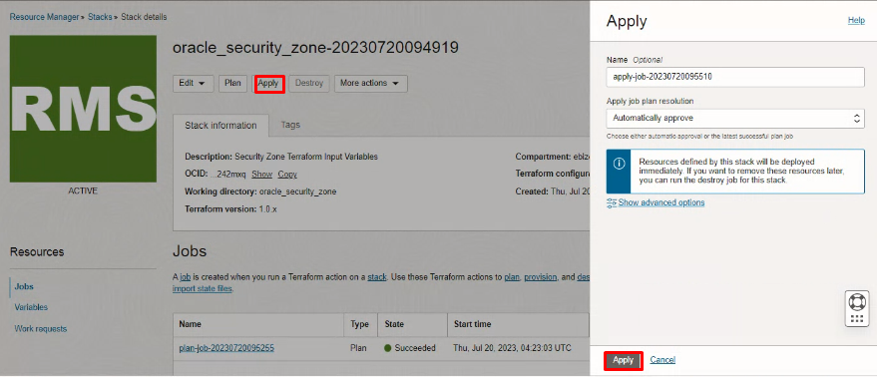
Verify the Apply is successful.

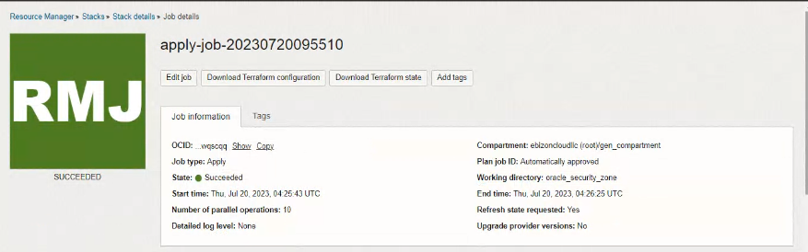
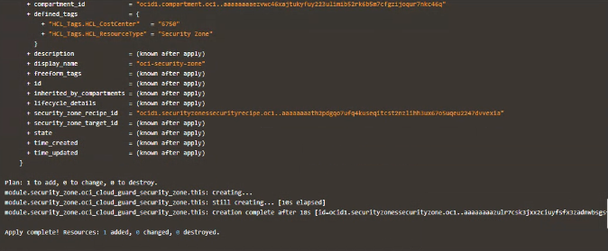

Verify in the Console

Go to OCI Console Identity and Security Security Zone Recipes

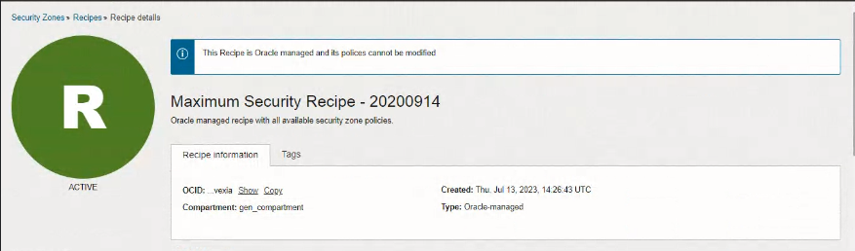

Go to OCI Console Identity and Security Security Zone Overview

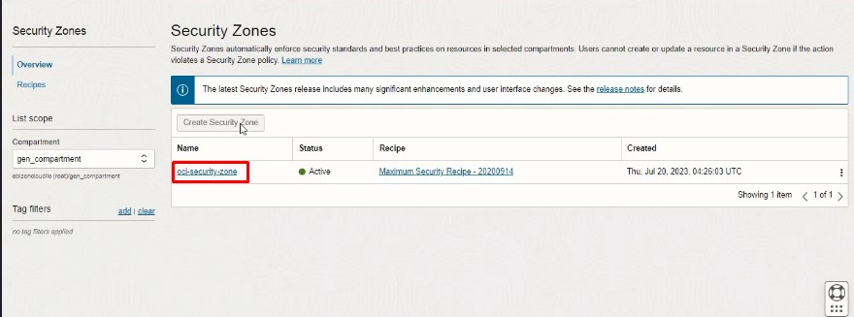

Go to OCI Console Identity and Security Security Zone Security Zone details

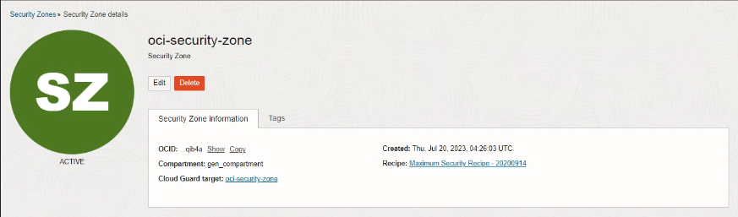

Destroy the stack

Create a destroy job in Resource Manager to release resources associated with a stack and clean up the tenancy. Once destroyed data cannot be recovered from resources.

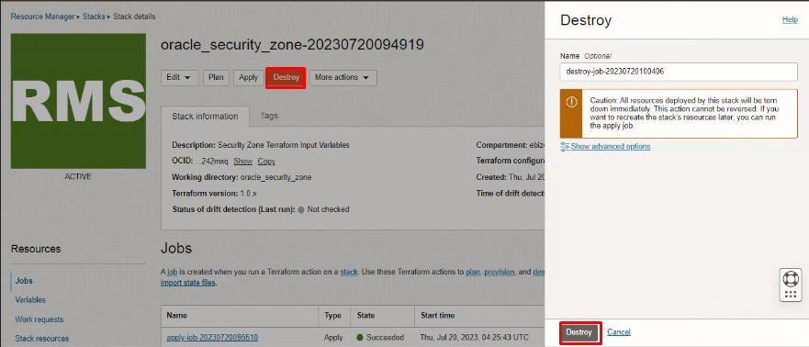

#END#

